**Azure Solution Architect Interview**

1: Introduction

Briefly introduce the e-commerce platform and its requirements for moving to Microsoft Azure.

Mention the key factors to be considered in the system design, such as availability, scalability, and cost optimization.

2: High-Level Architecture Overview

Present a high-level overview of the proposed Azure cloud architecture.

Identify the main components, services, and resources to be used in the design.

3: Availability and Redundancy

Explain the strategies to achieve high availability and fault tolerance in the Azure architecture.

Discuss the use of Azure Availability Sets, Availability Zones, and load balancing mechanisms.

4: Scalability and Elasticity

Describe how the architecture will handle scalability to accommodate fluctuations in user traffic.

Discuss the implementation of Azure Auto Scaling and other scaling mechanisms.

5: Cost Optimization

Outline the cost optimization strategies to ensure the platform runs efficiently.

Explain the use of Azure Reserved Instances, Spot Instances, and cost management tools.

6: Data Management and Storage

Present the design for managing data in Azure, including databases, data lakes, and backup strategies.

Discuss the use of Azure SQL Database, Cosmos DB, and Azure Blob Storage.

7: Security and Compliance

Highlight the security measures in place to protect the platform's data and resources.

Discuss Azure Network Security Groups, Azure Key Vault, and compliance with relevant regulations.

8: Monitoring and Performance Management

Explain the monitoring and performance management solutions for the Azure architecture.

Include insights on Azure Monitor, Application Insights, and performance optimization techniques.

9: Disaster Recovery and Backup

Describe the disaster recovery plan to ensure business continuity.

Discuss the use of Azure Site Recovery and backup mechanisms for critical data.

10: Conclusion

Summarize the key points covered in the presentation.

Emphasize the benefits of the proposed Azure cloud architecture for the e-commerce platform.

11: References

Provide a list of credible sources and documentation used to design the Azure architecture.

Note: Make sure to use appropriate diagrams, charts, and visuals to support your points throughout the presentation. Consider best practices, cost-effectiveness, and alignment with the organization's specific needs while designing the Azure cloud architecture.

**Ecommerce Application**

**Function Requirement:**

Product Search, Add to Cart, Order Prepared & Completed, Mail to User

**NFR**: Security, Governance, Identity, Logging, Monitoring

**1: Introduction**

Briefly introduce the e-commerce platform and its requirements for moving to Microsoft Azure.

Mention the key factors to be considered in the system design, such as availability, scalability, and cost optimization.

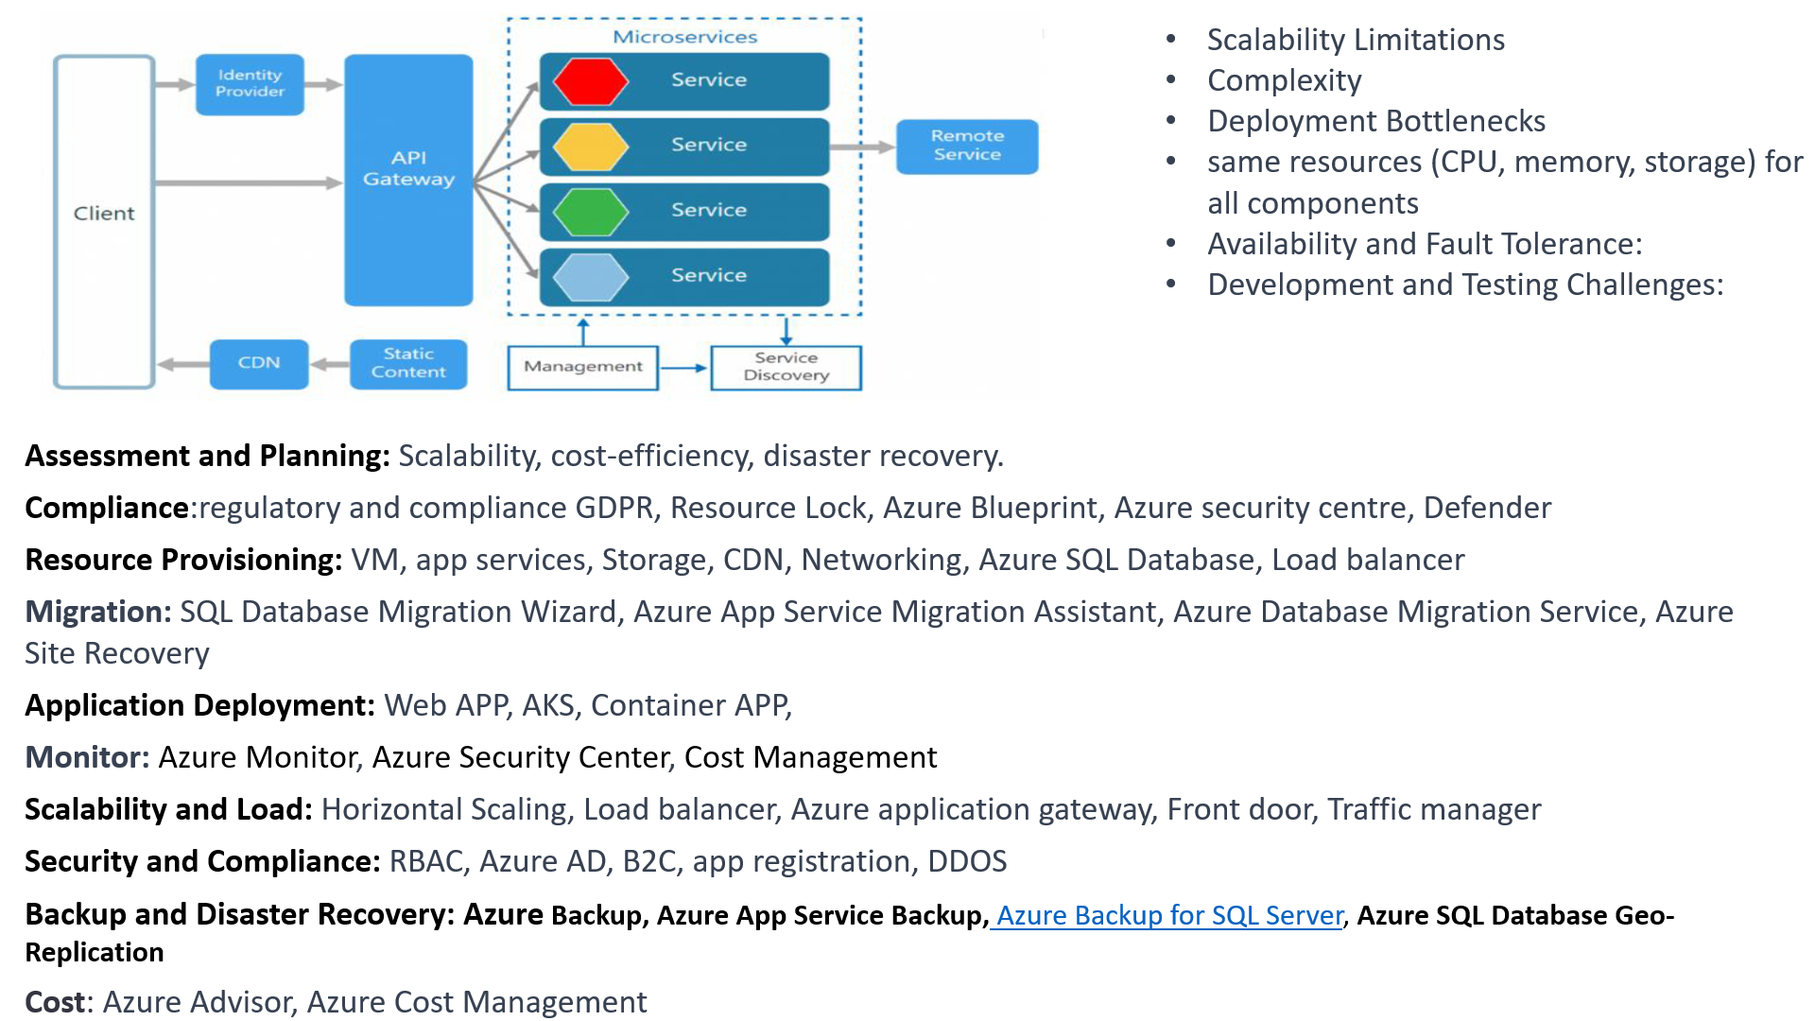

**2: High-Level Architecture Overview**

High Level Architecture:

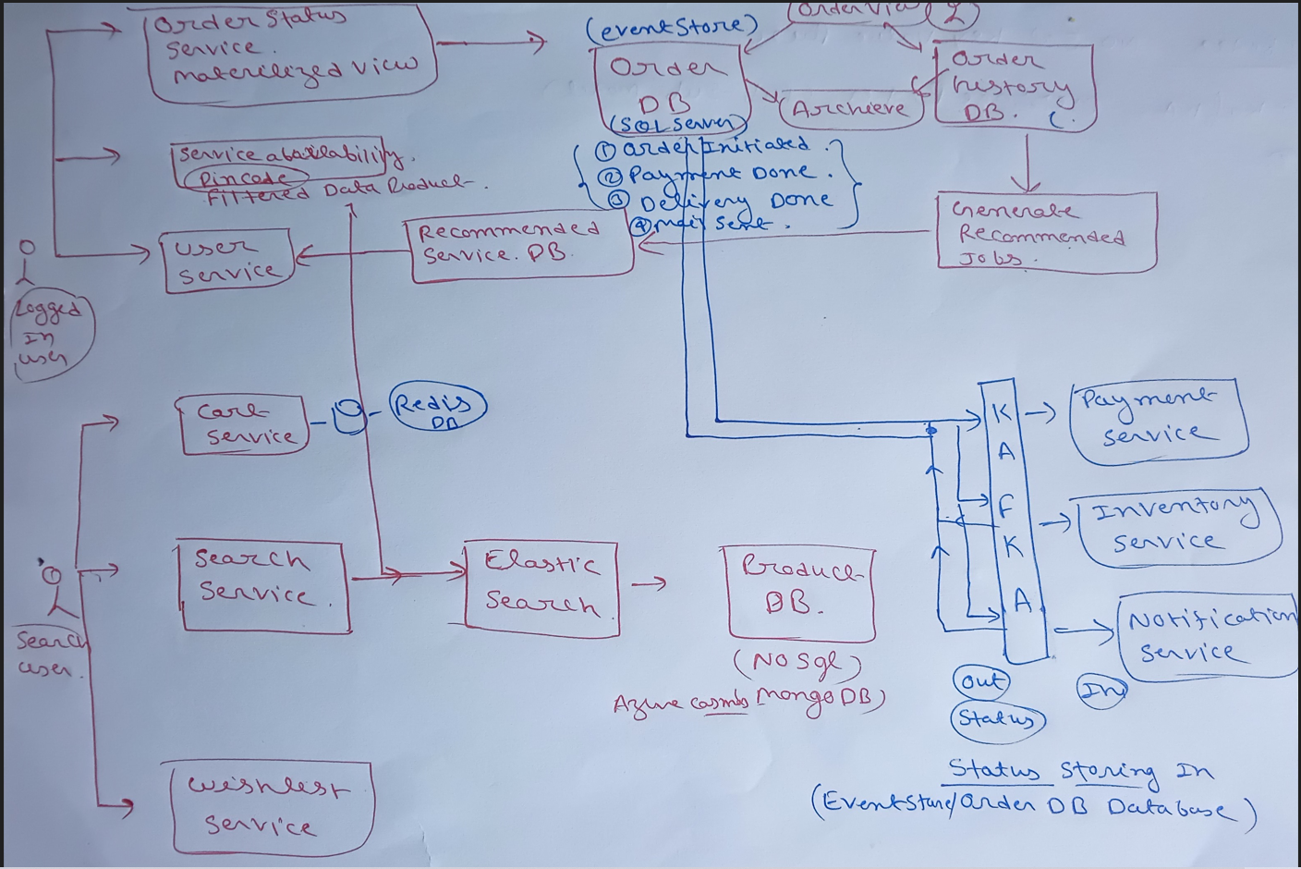

Component High level architecture

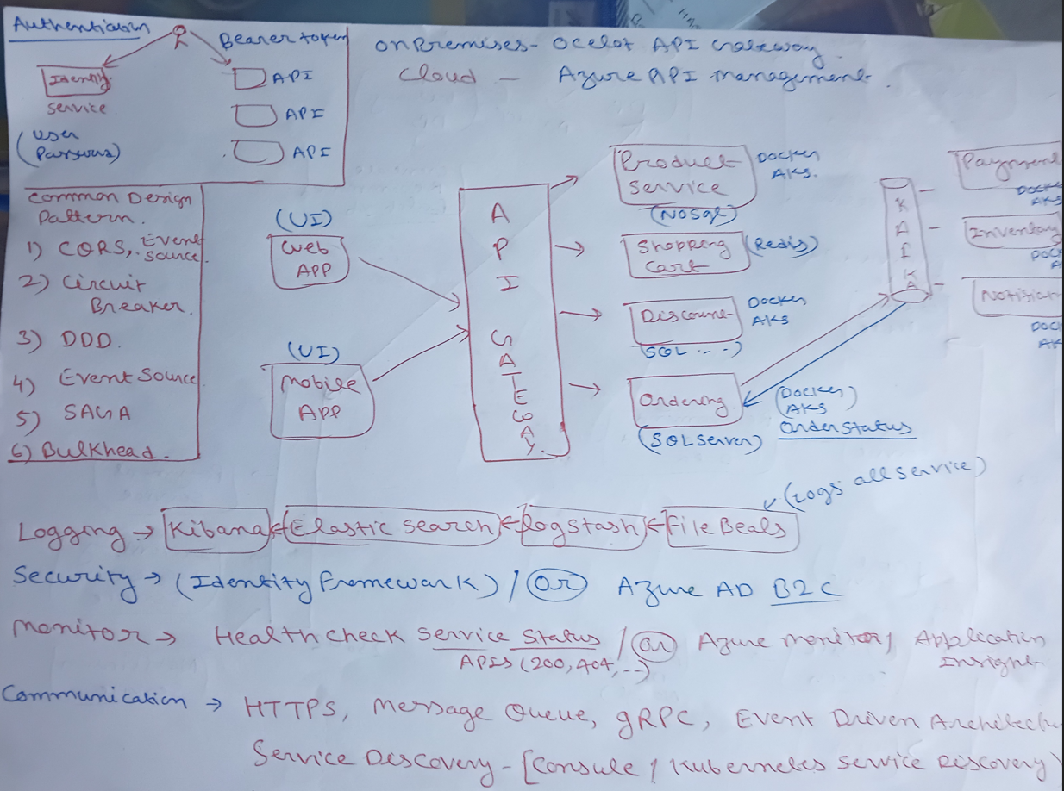

Present a high-level overview of the proposed Azure cloud architecture.

Identify the main components, services, and resources to be used in the design.

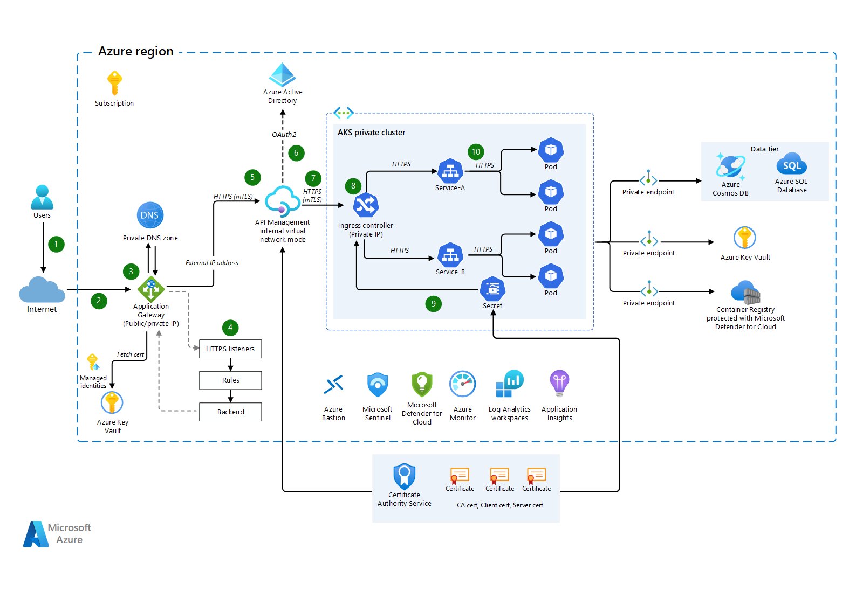

**3: Availability and Redundancy**

Explain the strategies to achieve high availability and fault tolerance in the Azure architecture.

Discuss the use of Azure Availability Sets, Availability Zones, and load balancing mechanisms.

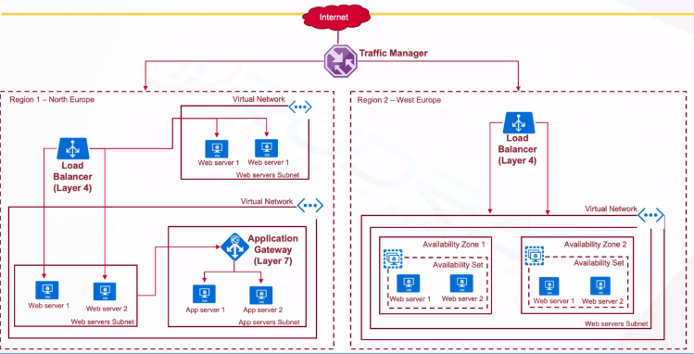

<https://www.javatpoint.com/azure-availability-zones-and-sets>

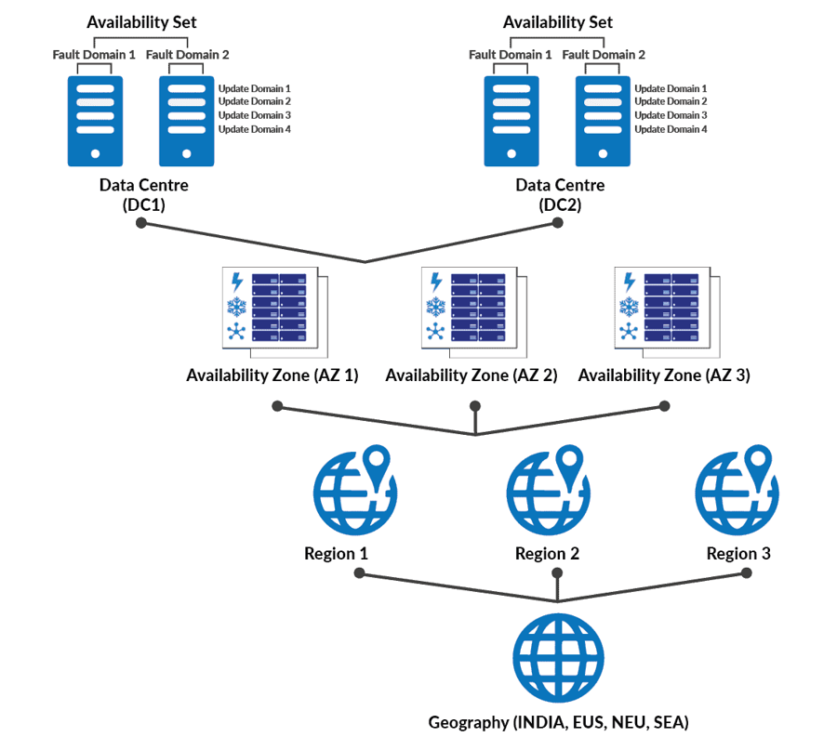

**4: Scalability and Elasticity**

Describe how the architecture will handle scalability to accommodate fluctuations in user traffic.

Discuss the implementation of Azure Auto Scaling and other scaling mechanisms.

1. **Azure Kubernetes Service (AKS):** If you're using containerized applications, AKS provides a managed Kubernetes service. You can set up Horizontal Pod Autoscaling (HPA) to adjust the number of pods based on CPU or custom metrics, ensuring your application scales with demand.

2. **Azure Load Balancer**: Azure Load Balancer can distribute incoming traffic across multiple virtual machines or instances. You can configure this to distribute traffic evenly and direct it to healthy instances.

3. **Azure Application Gateway**: This provides Layer 7 load balancing for your web applications. It can route traffic based on URL path or host headers, enabling more sophisticated routing and load balancing strategies.

4. **Azure Traffic Manager:** For global traffic management, Traffic Manager can distribute user requests across multiple Azure datacenters or regions, helping to optimize for high availability and performance.

5. **Azure CDN:** Content Delivery Network (CDN) services in Azure can cache and deliver static content from edge servers globally, reducing the load on your application servers.

6 .**Azure Redis Cache**: Utilize Azure Redis Cache to offload frequently accessed data from your database and reduce the load on your database servers, which can improve application performance during traffic spikes.

7. **Azure Cosmos DB:** For globally distributed databases, Azure Cosmos DB provides automatic scalability, multi-region redundancy, and low-latency access to data, making it suitable for applications with global user bases.

**8. Azure SQL Database:** Use the built-in auto-scaling and performance tuning features of Azure SQL Database to dynamically adjust resources based on usage patterns and ensure that your database can handle varying levels of traffic.

9. **Azure Monitor and Application Insights**: Set up comprehensive monitoring and logging using Azure Monitor and Application Insights to gain insights into your application's performance and to set up alerts based on specific metrics.

10. **Azure Functions with Durable Entities:** For complex, stateful serverless workflows, you can use Azure Functions with Durable Entities, which allows you to maintain state across function executions and scale as needed.

11. Use CQRS, DDD, Circuit Breaker, Sharding pattern as best practices.

5: Cost Optimization

Outline the cost optimization strategies to ensure the platform runs efficiently.

Explain the use of Azure Reserved Instances, Spot Instances, and cost management tools.

Azure Reserved Instances using Azure portal

use tools like Azure Cost Management, and review the Azure Pricing Calculator

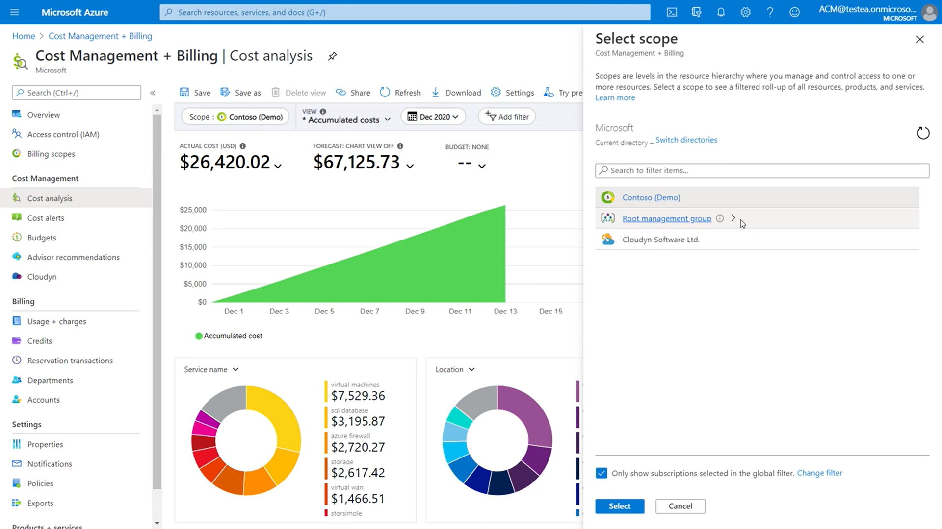

Daily or Weekly Cost Report:

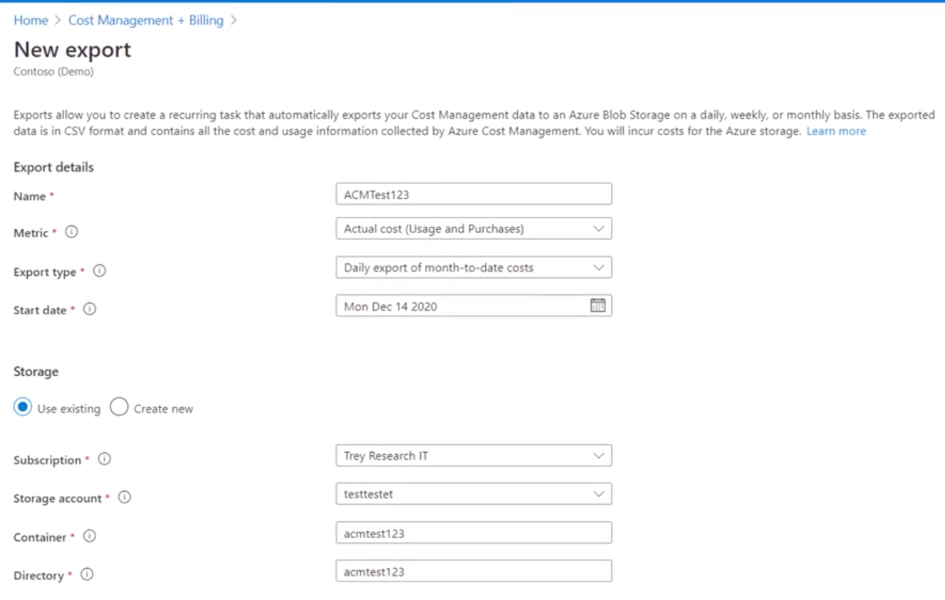

**6: Data Management and Storage**

Present the design for managing data in Azure, including databases, data lakes, and backup strategies.

Discuss the use of Azure SQL Database, Cosmos DB, and Azure Blob Storage.

1. Azure SQL Database Base

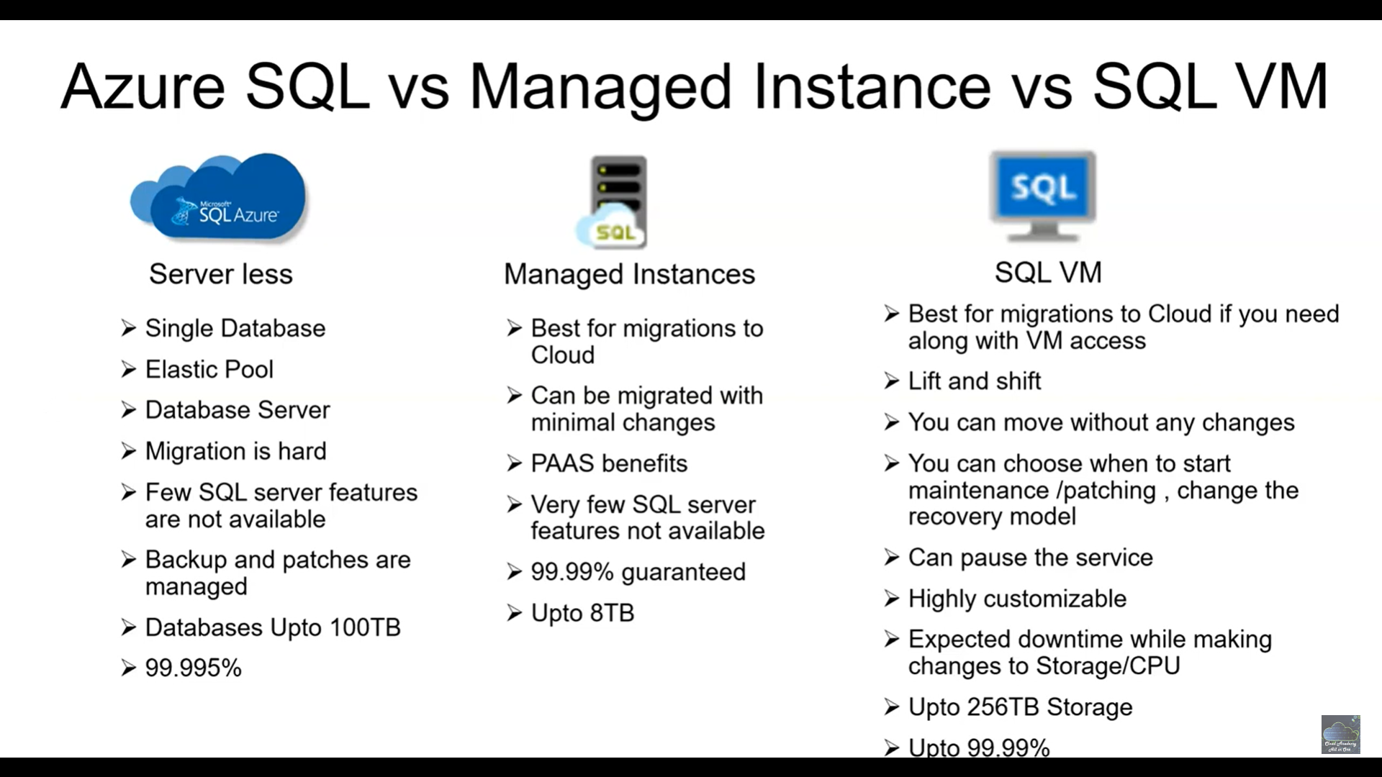

**Azure CosmosDB:** If customer is looking NO SQL Database (Json different data format structure. Example Shirts (Small, Medium, Large), Television model different structure then No SQL for storing data is best choice.

Global availability and low-latency data access.

High availability and fault tolerance.

Scalability to handle variable workloads and data growth.

Support for multiple data models.

Complex query and data retrieval needs.

Integration with other Azure services and tools.

**Below benefit :**

**Multi-Model Database**: document (JSON), key-value, graph, and column-family

**Security and Compliance**: (security features, including firewall rules, virtual network service endpoints, and encryption at rest). compliant with several industry standards and regulations, such as GDPR, HIPAA, and ISO.

**High Availability and Disaster Recovery**: With automatic failover, Cosmos DB ensures that your data remains available even in the event of regional failures. It also offers point-in-time restore for data recovery.

**Globally Distribution**

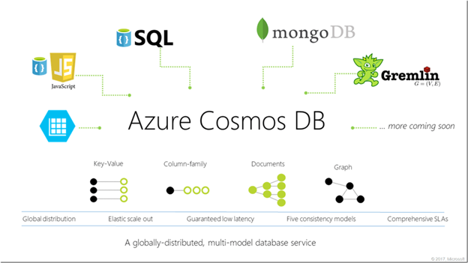

**Backup Strategy**

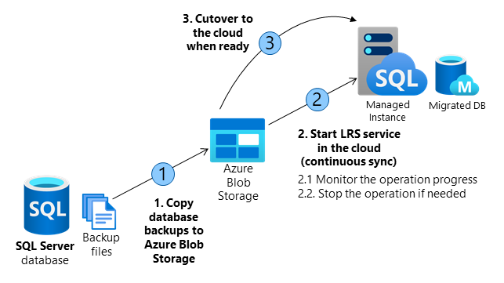

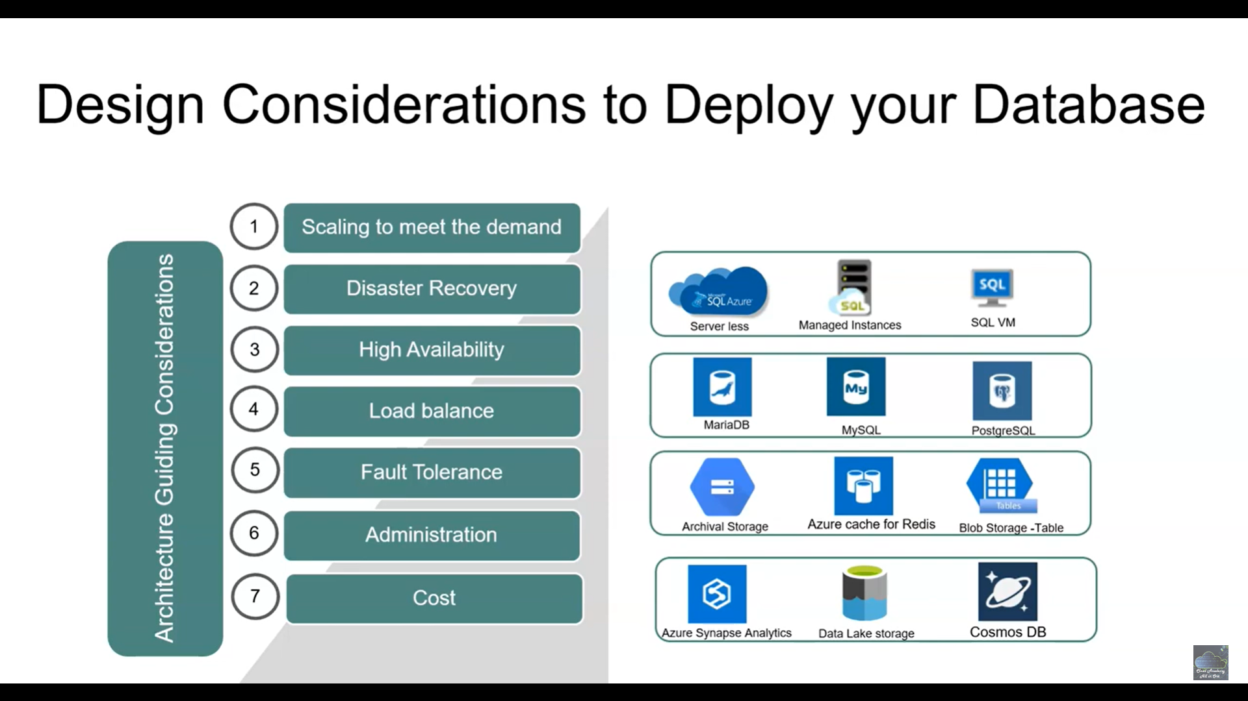

7: Security and Compliance

Highlight the security measures in place to protect the platform's data and resources.

Discuss Azure Network Security Groups, Azure Key Vault, and compliance with relevant regulations.

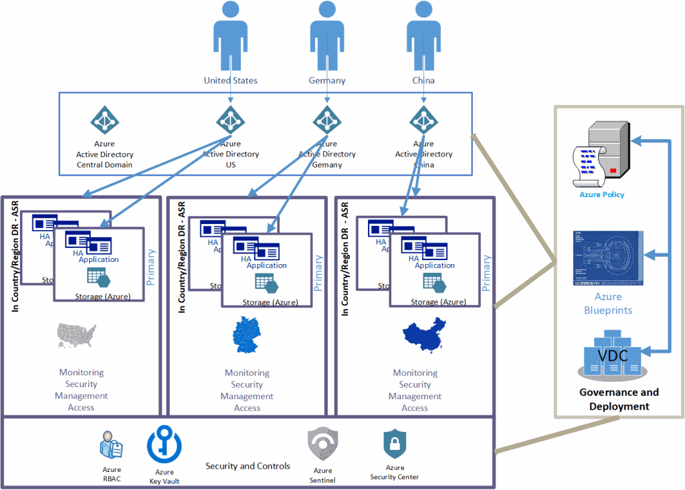

**Security components**

#### Azure Active Directory (Azure AD)

ability to create sub-domains that can be managed and contain only those identities relevant to that country or region. Azure AD also provides functionality to differentiate between business-to-business relationships (B2B) and business-to-customer relationships (B2C).

[Azure Sentinel](https://docs.microsoft.com/en-us/azure/sentinel/) is a scalable, cloud-native, security information event management (SIEM), and security orchestration automated response (SOAR) solution.

[Azure Key Vault](https://docs.microsoft.com/en-us/azure/key-vault/key-vault-overview) helps safeguard cryptographic keys and secrets that cloud applications and services use

#### Role-based access control

[Azure Security Center](https://docs.microsoft.com/en-us/azure/security-center/security-center-intro) is a unified infrastructure security management system that strengthens the security posture of your datacenters.

### Governance components

#### Azure Policy

[Azure Policy](https://docs.microsoft.com/en-us/azure/governance/policy/overview) is a service in Azure that you use to create, assign, and manage policies. These policies enforce different rules and effects over your resources, so those resources stay compliant with your corporate standards and service level agreements

### Infrastructure components

[Azure Site Recovery (ASR)](https://docs.microsoft.com/en-us/azure/site-recovery/site-recovery-overview) provides data replication and disaster recovery services between Azure Regions, or between on-premise environments and Azure.

**8: Monitoring and Performance Management**

Explain the monitoring and performance management solutions for the Azure architecture.

Include insights on Azure Monitor, Application Insights, and performance optimization techniques.

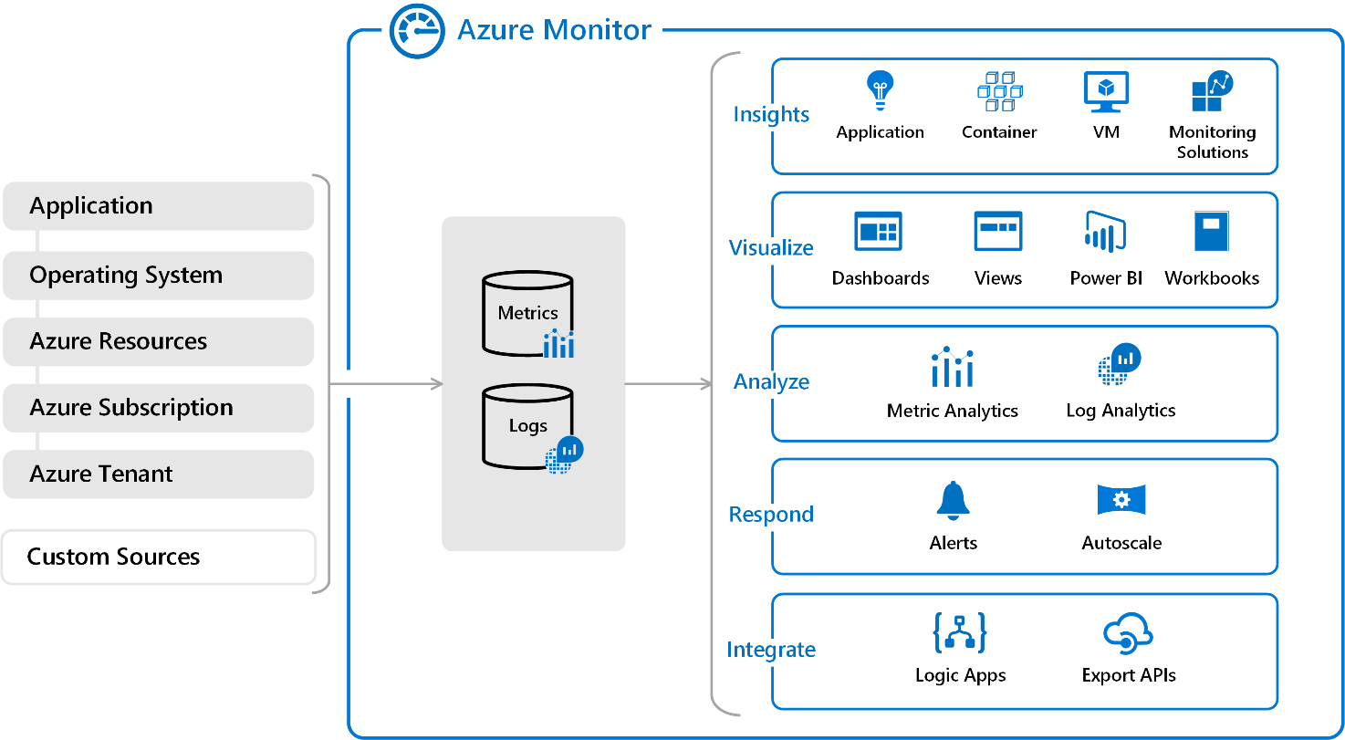

**9: Disaster Recovery and Backup**

Describe the disaster recovery plan to ensure business continuity.

Discuss the use of Azure Site Recovery and backup mechanisms for critical data.

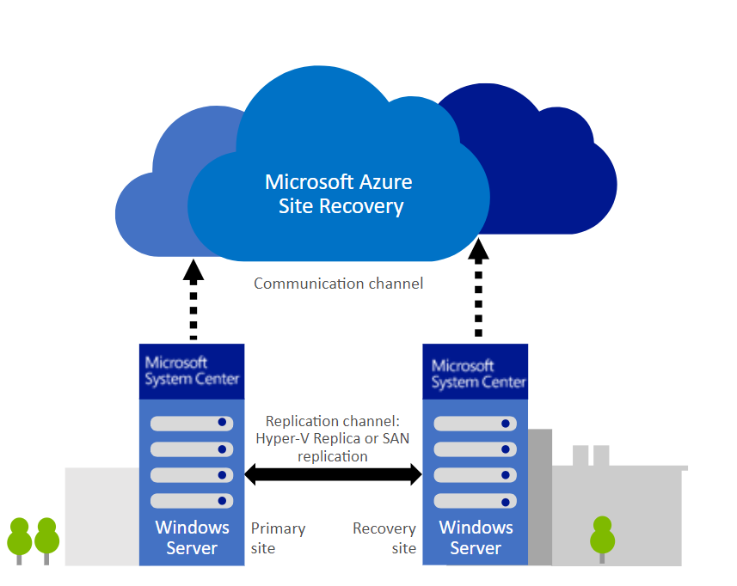

## Key Features and Capabilities

**Replication to Azure:**It provides businesses with the ability to replicate their critical workloads and data to Azure, which serves as a secondary data center for disaster recovery.

**Automated Failover:**It provides businesses with automated failover capabilities that ensure that critical workloads and data are always available in the event of a disaster.

**Testing and Validation:**It provides businesses with the ability to test and validate their disaster recovery plans before a disaster occurs. This ensures that businesses are prepared and can quickly recover in the event of a disaster.

**Multi-VM Application Consistency:**It provides businesses with the ability to replicate multi-VM applications and ensure that they are recovered in a consistent state.

**Application-level Recovery:**It provides businesses with the ability to recover critical applications, [including SQL Server](https://k21academy.com/microsoft-azure/migrate-sql-server-to-an-azure-sql-managed-instance-online/), SharePoint, and Exchange, in a matter of minutes.

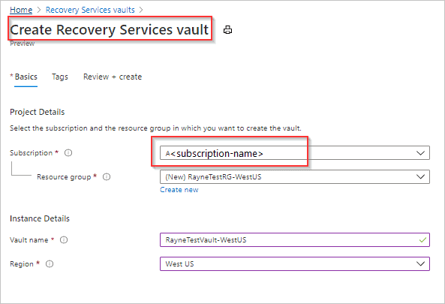

### Prepare your on-premises environment:

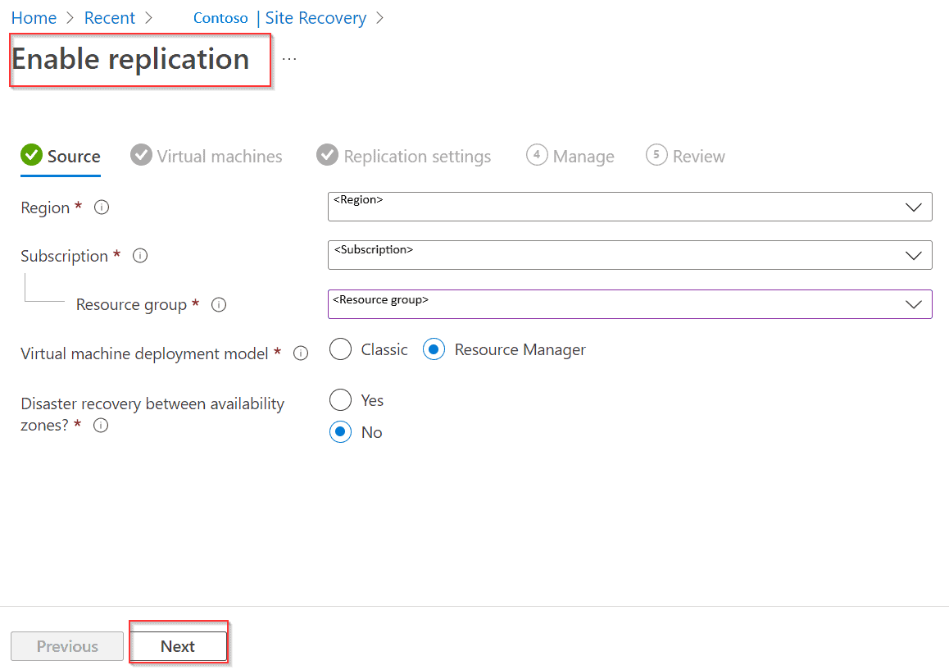

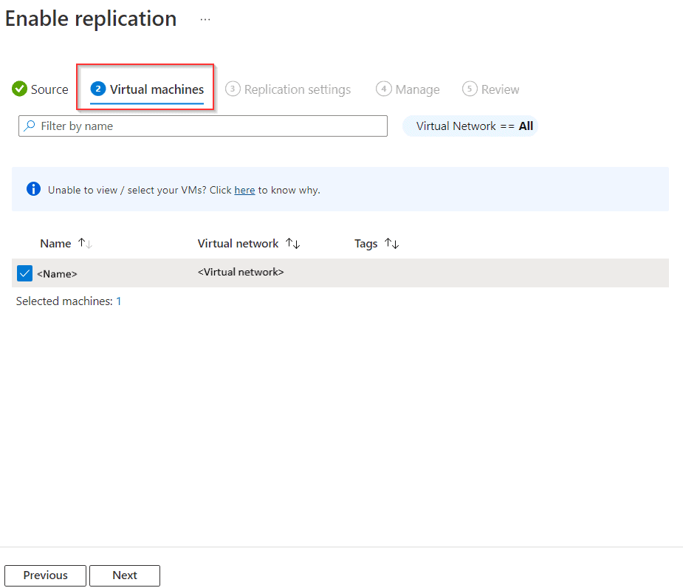

### Test the replication:

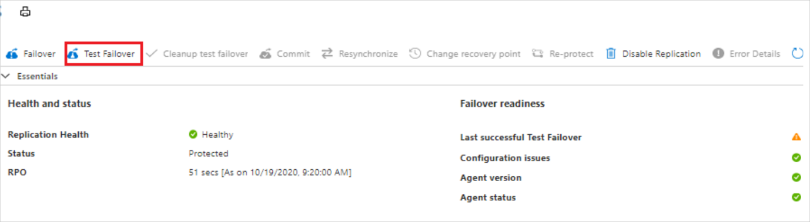

### Enable disaster recovery:

Once you have tested the replication process, you can enable disaster recovery by initiating a failover. This switches your production environment to the replicated virtual machines in Azure, ensuring that your applications and data remain available in the event of a disaster.

### 6. Monitor and manage the disaster recovery environment:

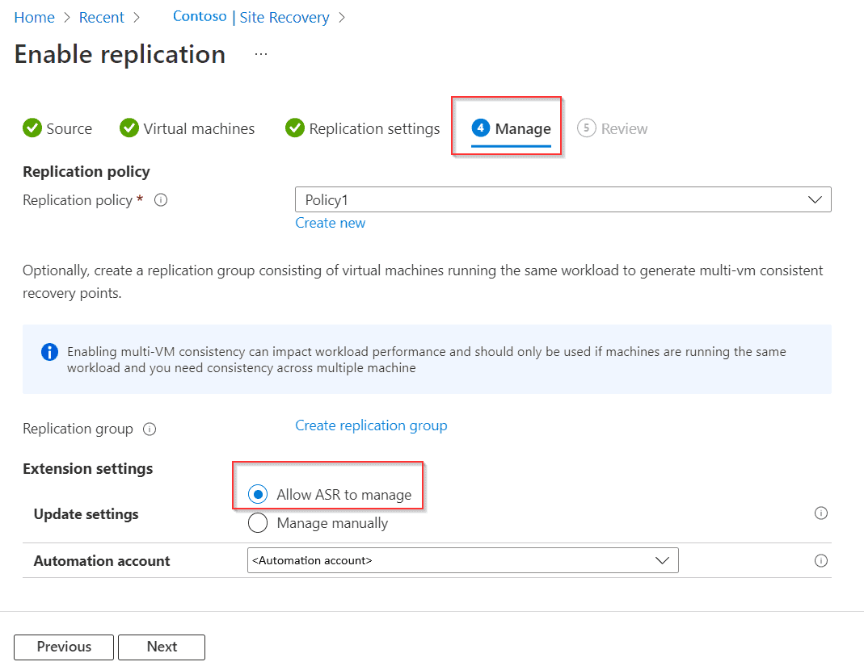

Finally, it is important to monitor and manage your disaster recovery environment on an ongoing basis. This includes monitoring replication health, managing failover settings, and performing regular disaster recovery drills to ensure that your environment is fully prepared for a disaster.

**Other way for Backup :**

**Regular Database Backups**:

-- Full Backup

BACKUP DATABASE YourDatabaseName TO DISK = 'C:\Backup\YourDatabaseName_FULL.bak'

-- Differential Backup

BACKUP DATABASE YourDatabaseName TO DISK = 'C:\Backup\YourDatabaseName_DIFF.bak' WITH DIFFERENTIAL

-- Transaction Log Backup

BACKUP LOG YourDatabaseName TO DISK = 'C:\Backup\YourDatabaseName_Log.trn'

**Database Snapshots:**

Create database snapshots to capture a point-in-time copy of the database. This can be useful for recovery if data gets accidentally modified or deleted.

CREATE DATABASE YourSnapshotName ON

(NAME = YourDatabaseDataFile, FILENAME = 'C:\Snapshot\YourSnapshotFile.ss')

AS SNAPSHOT OF YourDatabaseName;

**10: Conclusion**

Summarize the key points covered in the presentation.

Emphasize the benefits of the proposed Azure cloud architecture for the e-commerce platform.

|  |  |
| --- | --- |
| **Cloud Services for Scalability** | auto-scaling capabilities, high availability |
| **Containerization** | containers (Docker) to package |
| **Container Orchestration** | Using AKS |
| **Load Balancing** | distribute incoming traffic across multiple instances of your API |
| **Database Scalability** | Azure SQL Database, AWS RDS, or NoSQL databases like Cosmos DB or DynamoDB. |
| **Caching** | (Redis) to reduce the load on your database and improve response times. |
| **Microservices Architecture:** |  |
| **Health Checks and Monitoring** | Azure Application Insights |
| **Auto-scaling** | increase or decrease the number of instances based on traffic |
| **CDN** | Use a Content Delivery Network (CDN) to cache and distribute static assets to reduce the load on your API server. |
| **CI/CD Pipeline:** | Implement a robust CI/CD pipeline to automate deployment and ensure consistency. |
|  |  |
| **Authentication and Authorization:** | OAuth2 or JWT, to protect your API. |
| **Data Partitioning** | data partitioning strategies to distribute the data load |
| **Redundancy and Failover** | Azure Storage supports account failover for geo-redundant storage accounts. Create a disaster recovery plan for your storage accounts if the endpoints in the primary region become unavailable. |
| **Logging and Error Handling** | Kibana, Elasticsearch, Logstash, Kibana |
| **Rate Limiting and Throttling** | Rate limiting is a strategy for limiting network traffic.  Throttling is the process of limiting the number of API requests a user can make in a certain period. |
| **Versioning** | versioning for your APIs to allow for changes without breaking existing clients |
| **Security Best Practices:** | Keep your dependencies up-to-date, avoid storing sensitive information in code, and regularly conduct security audits. |
| **Testing for Scalability:** | Test load - Apache JMeter |
| **Backup and Disaster Recovery** | data and service availability in case of unexpected failures |
| **Cost Optimization** | Monitor and optimize your infrastructure to control costs |
| **RTO & RPO** | Recovery Point Objective (RPO) and Recovery Time Objective (RTO) are two of the most important parameters of a disaster recovery or data protection plan. |
| **Mandatory Design Pattern** | Retry & Circuit Breaker pattern, **CQRS for best practice** |

**11: References**

Provide a list of credible sources and documentation used to design the Azure architecture.

Note: Make sure to use appropriate diagrams, charts, and visuals to support your points throughout the presentation. Consider best practices, cost-effectiveness, and alignment with the organization's specific needs while designing the Azure cloud architecture.

|  |
| --- |
| **1. Web Application Layer:**   * **Azure App Service**: Host your e-commerce website using Azure App Service. This managed service makes it easy to deploy, scale, and manage your web applications. * **Auto Scaling**: Configure auto-scaling to automatically adjust the number of web app instances based on traffic load. * **Content Delivery Network (CDN)**: Use Azure CDN to deliver static assets like images, stylesheets, and JavaScript files, reducing latency and improving page load times.   **2. Database Layer:**   * **Azure SQL Database**: Use Azure SQL Database for your relational database needs. It provides high availability, scalability, and built-in security features. * **Azure Cosmos DB**: For scenarios requiring NoSQL databases, consider Azure Cosmos DB for its global distribution, low latency, and multi-model support. * **Database Replication**: Implement database replication for failover and disaster recovery using Azure SQL Database geo-replication or AlwaysOn Availability Groups.   **3. Authentication and Authorization:**   * **Azure Active Directory (Azure AD)**: Integrate Azure AD for identity and access management, including single sign-on and multi-factor authentication for users and administrators.   **4. Load Balancing:**   * **Azure Load Balancer**: Use Azure Load Balancer to distribute incoming traffic to your web application instances for load balancing and high availability.   **5. Caching:**   * **Azure Cache for Redis**: Implement caching to reduce database load and improve application performance. Azure Cache for Redis is a fully managed, in-memory cache.   **6. Search and Analytics:**   * **Azure Search**: Implement search capabilities for product catalog and content. Azure Search provides features for full-text search, filtering, and faceted search. * **Azure Application Insights**: Monitor and gain insights into your application's performance, user behavior, and error tracking.   **7. Messaging:**   * **Azure Service Bus**: Use Azure Service Bus for asynchronous communication and messaging between different components of your e-commerce platform.   **8. Storage and File Handling:**   * **Azure Blob Storage**: Store and serve product images, media files, and user uploads using Azure Blob Storage.   **9. Security:**   * **Azure Security Center**: Monitor, assess, and improve the security posture of your e-commerce platform with Azure Security Center. * **Azure Web Application Firewall (WAF)**: Protect your web application from common web vulnerabilities and DDoS attacks using Azure WAF.   **10. Content Management:**   * **Azure Content Delivery Network (CDN)**: Cache and deliver dynamic content to users with low latency using Azure CDN.   **11. Logging and Monitoring:**   * **Azure Monitor**: Set up Azure Monitor to track the performance and availability of your Azure resources. * **Azure Log Analytics**: Centralize and analyze logs from various Azure services using Azure Log Analytics.   **12. Disaster Recovery:**   * **Azure Backup**: Regularly back up your data and configurations using Azure Backup for disaster recovery. * **Azure Site Recovery**: Implement a disaster recovery plan using Azure Site Recovery for business continuity.   **13. Compliance and Governance:**   * **Azure Policy and Blueprints**: Enforce organizational policies and ensure regulatory compliance using Azure Policy and Blueprints. |